UNIT - 2

OPERATIONS MANAGEMENT and MARKETING MANAGEMENT

**Plant Location**

Introduction and meaning:

Plant location refers to the choice of region and the selection of a particular site for setting up a business or factory.

But the choice is made only after considering cost and benefits of different alternative sites. It is a strategic decision that cannot be changed once taken. If at all changed only at considerable loss, the location should be selected as per its own requirements and circumstances. Each individual plant is a case in itself. Businessman should try to make an attempt for optimum or ideal location.

Factors Affecting the Plant Location:

When the location of an industrial unit is preplanned, several factors are taken into consideration and carefully analyzed because the location once chosen cannot be changed often as frequent changes in location leads to losses. The main factors, which influence the choice of location, are as follows:

1. **Primary factors**
2. Nearness to market
3. Nearness to supply of materials
4. Availability of labour
5. Transportation and Communication facilities
6. Availability of power and fuel
7. Supply of capital

**B**. **Secondary factors**

1. Natural factors
2. Government incentives
3. Historical and religious factors
4. Initial start and goodwill
5. Financial and other aids
6. Facilities
7. Amenities of particular site
8. Climate
9. Availability of Water
10. Political factors
11. Miscellaneous factors

**Primary factors**:

1. Nearness to Market: If the plant is located close to the market the cost of transportation can be minimized. This also helps the producers to have direct knowledge of the requirements of the customers.
2. Nearness to supply of raw materials: As far as possible the site selected should be near the source of raw materials, so that the cost of transportation can be minimized and storing cost can be reduced due to shorter lead time
3. Availability of labour: Availability of right kind of labour force in required number at reasonable rates is also a deciding factor in selection of site
4. Transport and Communication facilities: Generally, industries have a tendency to locate the industrial units near the railway station, highway or port areas.
5. Availability of power and fuel: Coal, electricity, oil and natural gas are the important sources of power in the industries. Power shortage leads to tremendous losses due to stoppage of machinery. Ex. Tata iron and steel industry is established near the coalmines of Bihar.
6. Supply of Capital: Large scale production, mechanization and big industries require large amounts of capital for a long period. ‘’ Finance is the life blood of an industry ‘’. The place where financial institutions are ready to assist the industry becomes an industrial hub. Cities like Mumbai, Pune are the centers of industries, because they enjoy better credit facilities. Certain states in our country provide easy loans on subsidized rates, machinery, built-up sheds, etc., to attract industries.

**Secondary factors**:

7. Natural factors: Land, water, climate are some important natural factors that play an important role in plant location in case of industries like cotton, sugar and jute.

8. Government incentives: The government by giving certain incentives like tax exemptions, price subsidies etc, may bring about the development of industries in backward areas thus resulting in the regional balancing of industries.

9. Historical and Religious factors: Some industries grow because of the historical and religious factors of those cities.

10. Initial start and goodwill: Once an industry is started, other industries also develop at that place. Government rest ructions play a negative role in the location decision. Industries are not permitted to be started or expanded in certain developed urban areas therefore some industries get located at a place because some industrialists start the industry at that place at an early stage.

11.Financial and other aids: For the development of back ward regions central as well as state government provide certain incentives and facilities such as cash subsides, concession, financial assistance, land, power and other facilities at cheaper rates, tax concession etc.

12. Facilities: Factors like an enterprising spirit, innovation, technical know-how and an industrious nature of policy and a favourable government policy create a favourable atmosphere for the purpose of the establishment of industries.

13Amenities of site: Amenities of a particular site like the level of ground, the nature of vegetation and location of allied activities have some influence in determining industrial location. The social amenities include suitable housing and medical facilities serve as an attraction to the labourers.

14. Climatic conditions: Climatic conditions largely affect certain production processes and also the efficiency of the employees.

Ex. Textile mills require moist climate that’s why these plant located at Mumbai and Ahmadabad.

15. Availability of water: Water is used in industries for processing as in paper in chemical industries, for generation of power in hydroelectric power, plants and also require for drinking and sanitary purpose also.

16. Miscellaneous:

* Sufficient supply and proper disposal of water

* Availability of fire-fighting facilities

* Availability of recreational. Medical and educational facilities

* Attitudes of the community

* Aspirations of the people

Also consider to locate the site.

**PLANT LAYOUT**

Meaning and Definition

After deciding the proper site for locating an industrial unit, next important point to be considered by an entrepreneur is to decide about the appropriate layout for the plant. Plant layout is primarily concerned with the internal set up of an enterprise in a proper manner.

It is concerned with the orderly and proper arrangement and use of available resources viz., men, money, machines, materials and methods of production inside the factory. A well designed plant layout is concerned with maximum and effective utilization of available resources at minimum operating costs.

**Definitions**

“Plant layout is the arrangement of machines, work areas and service areas within a factory”. —George R. Terry

“Any arrangement of machines and facilities is layout”. —F.G. Moore

**Objectives of Plant layout:**

A good plant layout tries to attain the following objectives:

1. To minimize the cost of material handling
2. To avoid industrial accidents
3. To eliminate bottlenecks through balancing of plant capacities
4. To increase material turnover through shorter operating cycles
5. To utilize the cubic area of the factory effectively
6. To eliminate, improve or confine objectionable operations
7. To increase the returns on the investments to the maximum extent by effective utilization of installed capacity
8. To utilize man-power resources effectively through elimination of idle time
9. To eliminate physical efforts required of operative workers
10. To provide better working conditions for the employees like lighting, ventilation
11. To maintain decency and orderliness inside the plant area
12. To provide better customer services through cheaper and better product supplies.

**Advantages of a good plant layout**:

Plant layout is the overall arrangement of the production process, storeroom, stockroom, and tool-room, material handling equipment, racks and sub stores, employee services and all other accessories required for facilitating the production in the factory.

As it encompasses production and service facilities and provides for the most effective utilization of the men, materials and machines constituting the process, it is a

Master blue print for coordinating all operations performed inside the factory. According to Moore, ‘’ A good layout is one which allows materials rapidly and directly for processing. This reduces transport handling, clerical and other costs down per unit, space requirements idle machine and idle man time.

**Symptoms of a Bad Layout**:

A poor or badly planned layout will generally show the following symptoms:

1. Congestion of machines, materials, parts, assemblies and even workers
2. Excessive amount of work in process
3. Poor utilization of available space
4. Long material flow lines
5. Some machines heavily loaded and some remaining idle for long periods
6. Delays in delivery
7. Excessive mental or physical strain on workers
8. Difficult to supervise and control properly

**Layout Design Procedure**:

The requirement of materials is central to all planning. The plan as a whole is made fist and details are added afterwards. The following are the steps involved in any layout plan.

1. The first step involves the determination of objectives and limitations.
2. The second step involves the collection of the input data and study of various activities involved in the process.
3. Next step is drawing a relationship diagram after determining the flow of materials and activity relationship. This step helps in getting a space relationship diagram.
4. In this step the space relationship diagram is modified by taking into consideration various factors and practical limitations.
5. As a result of modifications several alternative layouts emerge and the best among them is evaluated and selected.

PRINCIPLES OF PLANT LAYOUT

There are six basic principles of best plant layout. These are

1. Principle of overall integration
2. Principle of minimum distance
3. Principle of flow
4. Principle of cubic space
5. Principle of satisfaction and safety
6. Principle of flexibility
7. Principle pf overall integration:

According to this principle, the best layout is one which integrates the Men, Materials, Machinery, supporting activities and any other such factors that results in the best compromise.

1. Principle of minimum distance:

According to this principle, other things being equal, the best lay out is one in which men and materials have to move the minimum required distance between operations.

1. Principle of flow:

Other things being equal, the best layout is one which arranges the work area for each operation in the same order that forms, assembles the materials.

1. Principle of cubic space:

According to this, the best layout is one in which all the available space both vertical and horizontal is most economically and effectively used.

1. Principle of satisfaction and safety:

According to this, other things being equal the best layout is one which makes work satisfying and safe for workers.

1. Principle of flexibility: It means the best layout is one which can be adopted and rearranged at a minimum cost and least inconvenience.

**TYPES OF PLANT LAYOUT OR SYSTEMS OF PLANT LAYOUT**

The pattern of plant layout is basically decided by the relationship between the number of products and the production quantity. Plant layout is a specialized process. The major systems of plant layout are:

*Product layout (Line layout)

* Functional layout (Process layout)

* Fixed layout (Static layout)

* Combined layout (Group or Cellular layout)

### 1. Product or Line Layout:

If all the processing equipment and machines are arranged according to the sequence of operations of the product, the layout is called product type of layout. In this type of layout, only one product of one type of products is produced in an operating area. This product must be standardized and produced in large quantities in order to justify the product layout.

The raw material is supplied at one end of the line and goes from one operation to the next quite rapidly with a minimum work in process, storage and material handling.

Product layout

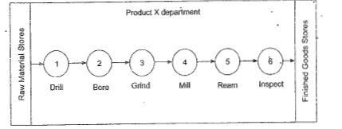

**Advantages:**

1. It is ideally suitable for a standard product where production requirement is high
2. It avoids bottlenecks
3. Better production control can be achieved
4. It requires less floor space compared to functional layout
5. Less skilled workers will serve the purpose
6. Production time is reduced
7. Smooth and continuous work flow
8. Effective control over production, quality, production planning and control
9. Reduction in material handling cost due to straight-line production flow

**Disadvantages:**

1. There is no flexibility of work
2. It is quite expensive as machines have to be special purpose machines
3. Expansion of this layout is difficult
4. It is difficult to increase production beyond the capacities of the production lines
5. Failure of even one machine leads to shutdown of the complete production line
6. Since there are no separate department for various types of work, specialization in supervision is also difficult
7. Any change in product requires re-balancing the line

### 2. Process or Functional Layout:

The process layout is particularly useful where low volume of production is needed. If the products are not standardized, the process layout is lower desirable, because it has creator process flexibility than other. In this type of layout, the machines and not arranged according to the sequence of operations but are arranged according to the nature or type of the operations. This layout is commonly suitable for non repetitive jobs.

Same type of operation facilities are grouped together such as lathes will be placed at one place; all the drill machines are at another place and so on.

Process layout

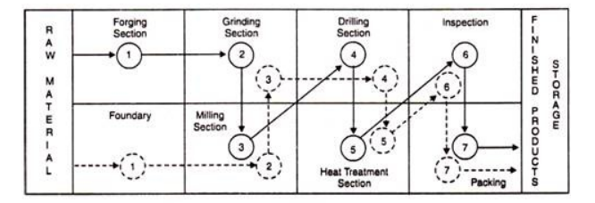

**Advantages:**

1. It involves a high degree of flexibility as any product with any design, as long as it requires the available process, can be manufactured with the same layout
2. Reduces investment as machines are used for general purpose
3. Greater flexibility in production is achieved
4. Capacity enhancement in different production lines can be easily achieved
5. Better utilization of men and machinery
6. Machine breakdown can be effectively prevented by shifting the work to other machines
7. Variety in different job orders make the work more interesting for the workers
8. Workers in one section are not affected by the nature of the operations carried out in another section

**Disadvantages:**

1. Efficient material handling is difficult to practice in process layout
2. It is quite expensive as machines have to be special purpose machines
3. Expansion of this layout is difficult
4. It requires more floor space than the product layout
5. High cost of supervision
6. It is difficult to control the production activities
7. Completion of same product takes more time

### 3. Fixed Position Layout:

This type of layout is the least important for today’s manufacturing industries. In this type of layout the major component remain in a fixed location, other materials, parts, tools, machinery, man power and other supporting equipment’s are brought to this location.

The major component or body of the product remain in a fixed position because it is too heavy or too big and as such it is economical and convenient to bring the necessary tools and equipment’s to work place along with the man power. This type of layout is used in the manufacture of boilers, hydraulic and steam turbines and ships etc.

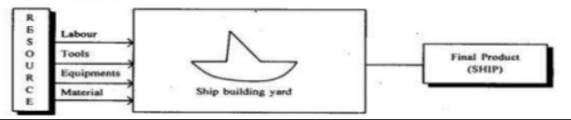

#### Advantages Offered by Fixed Position Layout:

1. Material movement is reduced
2. Capital investment is minimized.
3. The task is usually done by gang of operators, hence continuity of operations is ensured

4. Production centers are independent of each other. Hence, effective planning and loading can be made. Thus total production cost will be reduced.

5. It offers greater flexibility and allows change in product design, product mix and production volume.

#### Limitations of Fixed Position Layout:

1. Highly skilled man power is required.
2. Movement of machines equipment’s to production centre may be time consuming.

3. Complicated fixtures may be required for positioning of jobs and tools. This may increase the cost of production.

### 4. Combination Type of Layout:

This type of layout combines the advantages of both product and process layouts. A combination layout is possible where an item is being made in different types and sizes. In such cases machinery is arranged in a process layout but the process grouping is arranged in a sequence to manufacture various types and sizes of products. In this case it is important to note that, no matter the product varies in size and type but the sequence of operations remain same or similar. This type of layout is also useful when a number of items are produced in same sequence but none of the items are to be produced in bulk and thus no items justifies for an individual and independent line.

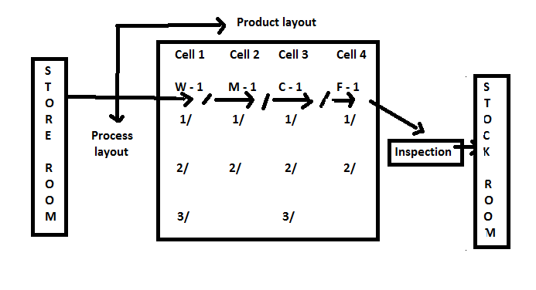

**Advantages:**

1. Less work-in-process
2. Reduces handling costs
3. Improves or enhances production control
4. Increases the responsibility of workers

**Disadvantages:**

1. Reduces the manufacturing flexibility
2. Increases the idle time of machines
3. Require huge capital expenditure
4. Machines cannot be replaced easily

**Methods of Production**

Some of the most important types of production are: (i) Job Production (ii) Batch production and (iii) Mass or flow production!

A production manager will have to choose most appropriate method for his enterprise.

Production methods may be broadly classified as Job Production, Batch production and Mass or Flow Production.

**Job production**: In this system, goods are produced according to the orders with this method; individual requirements of the consumers can be met. Each job order stands alone and is not likely to be repeated. This type of production has a lot of flexibility of operation and hence general purpose machines are required. Factories adopting this type of production are generally small in size.

**Advantages:**

1. It is the only method, which can meet the individual requirement.

2. There is no managerial problem, because of very less number of workers, and small size of concern.

3. Such type of production requires less money and is easy to start.

**Disadvantages**:

1. There is no scope for continuous production and demand

2. As the purchase of raw materials is less, hence cost of raw materials per unit will be slightly more.

3. For handling different type of jobs, only skilled and intelligent workers are needed, thus labour cost increases.

**Batch production**: This type of production is generally adopted in medium size enterprise. Batch production is in between job production and mass production. Batch production is bigger in scale than the job production. While it is smaller than that of mass production, batch production requires more machines than job production and fewer machines that the of mass production.

**Advantages:**

1. While comparing with mass production it requires less capital

2. Comparing with job production, it is more advantageous commercially.

3. If demand for one product decrease then production, for another product may be increased, thus the risk of loss is very less.

**Disadvantages:**

1. Comparing with mass production cost of scales and advertisement per unit is more

2. Raw materials to be purchased are in less quantity than that in mass production;

Therefore it is slightly costlier than that of mass production because less quantity discount is available.

**Mass production**: This method of production is used by concerns where manufacturing is carried on continuously in anticipation of demand though demand of the product may not be uniform through the year. In mass production, simplification and standardization of products are made with the help of specialized (one purpose) machineS, articles of standardized nature can easily and economically be produced on a large scale. There is a small difference between mass production and continuous production. This is mainly in the kind of product and its relation to the plant. In mass production plant and equipment are flexible enough to deal with other products, involving same production process. Where as in continuous or process production only standardized product in a sequence produced.

**Advantages:**

1. A smooth flow of materials from one work station to the next in logical order.

2. Since the work from one process is fed directly into the next, small in process inventories result

3. Total production time per unit short

4. Simple production planning control system is possible

5. Little skill is usually required by operations at the production line; hence training is simple, short and inexpensive.

**Disadvantages:**

1. A breakdown of one machine may lead to a complete stoppage of the line that follows the machine. Hence maintenance and repair is challenging job.

2. Since the product dictates the layout, changes in product design may require major changes in the layout.

3. Generally high investment is required owing to the specialized nature of the machines and their possible duplication in the line.

**Work Study**

Work study is one of the most important management techniques which are employed to improve the activities in the production. The main objective of work study is to assist the management in the optimum use of the human and material resources.

Definition: Work study refers to the method study and work measurement, which are used to examine human work in all its contexts by systematically investigating into all factors affecting its efficiency and economy to bring forth the desired improvement.

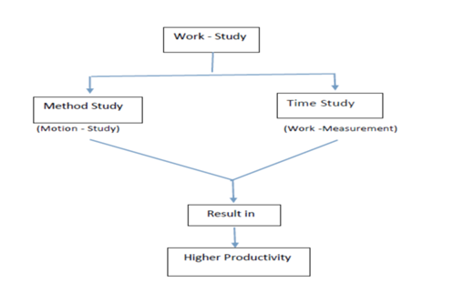

##### **Method Study:**

Method study is the systematic recording and critical examination of existing and proposed ways of doing work, as a means of developing and applying easier and more effective methods and reducing cost. It is also called motion study.

##### Method study is used in order to affect solutions to a variety of production problems. Such as work place layout, equipment design, product/process design, worker fatigue and so on. The basic procedure of method study procedure is illustrated in this figure.

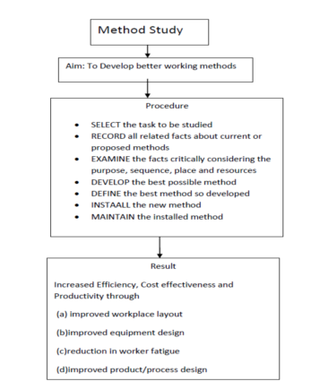

**Basic procedure for Method study**:

1. **Select**: The task to which the method study principles are to be applied is to be identified and the underlying objectives, such as saving the costs, increasing productivity or eliminating unnecessary motions by the worker, and so on, are to be specified.
2. **Record**: The correct process of doing the job has to be recorded. While doing so, every detail, however small it may be, has to be identified. Where the process is too long, involving many stages of production, inspection or transportation, the present process of doing the job is recorded sufficiently, together with all the relevant information, using the process chart symbols.

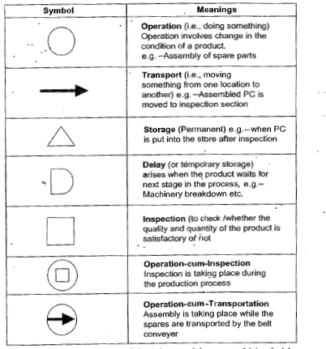

1. **Examine**: The recorded events are to be critically examined in a sequence, even it the extent of questioning the very purpose of an activity.
2. **Develop and Define**: Based on the recorded data, the alternative methods of doing te same job more effecively are to be identified and evaluated. From these alternatives the best one is selected and developed to suit the requirements.
3. **Install**: The new method so developed is to be installedin a phased manner. As a part of installation, adequate planning of schedules and deployment of resources should be taken care of. Once the method is adopted, the workers have to be retained, the equipment has to be provided, and the method has to be tested in order to seek improvement.
4. **Maintain**: It should be ensured that the method is used in the manner intended. Complaints and improvements in productivity should be registered. From time to time it should be monitored. The progress has to be reviewed in the light of the experiences of the opersting and concerned staff.

##### **Work Measurement:**

Work measurement also called time study, establishes the time taken by a qualified worker to complete a specified job at a defined level of performance. These techniques are used to answer the questions – how long? And when?

**Basic outline of Work Measurement procedure**

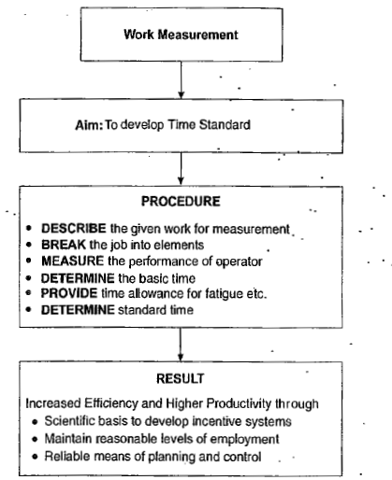

##### **Procedure for Work Measurement:**

1. **Select**: The work to be studied and determine the objectives of the study

2. **Record**: All the relevant data relating to circumstances in which the work is being done, the methods to be used breakdown the job into its elements

3. **Examine**: The recorded data and the detailed breakdown critically to ensure the most effective method and motions are being used and that unproductive elements are separated from productive elements.

4. **Measure**: The time required to complete each element using the appropriate work measurement techniques and calculate the time required to complete the work cycle which is known as basic time.

5.**Compile**: The standard time for the operation or work place, in case of stop watch time study the various allowances to cover relation, personal needs etc. are added to the basic time to estimate the standard time.

**Techniques of work measurement**:

a) Time study

b) Synthesis from standard data

c) Predetermined Motion Time System (PMTS)

d)Analytical estimating

e)Work Sampling

**Time study**: It is defined as the art of observing and recording the time required to do each detailed element of all industrial operation.

1. Time measuring devices:

1) Stop Watch 2) Motion picture camera 3) Time recording machine 4) Electronic timer.

1) Stop Watch:

i) Decimal minute stop watch: In this type of watch the movements is started and stopped by moving the slide ―A‖, forward and backward respectively are complete revolution of large hand represents 1 minute and since the dial is divided into 100 parts reading to within 0.01 minutes can be obtained. Every time the large hand make one revolution the small hand will register 1 minute and is able to register up to 30 minutes.

ii. Decimal hour stop watch: The dial in this watch is divided into 100 parts. The needle completes 10 revolutions in one hour. The least count in this watch is 0.001 hours. The small dial of this watch is divided into 30 equal spaces (representing 0.01 hour) and the small needle makes 31/3 revolutions in one hour.

1. Motion picture camera: Every element of the operation involving motion of the workers is made into film through motion picture camera when this film is run at a slow speed through a projector; the time of each element is recorded using a stopwatch.
2. Time recording machine: A moving tape is run is this machine at a uniform velocity of 10 inches/minutes with the help of electric motor. The machine has two keys: one key, when pressed, indicates starting of an operation, and the other key used to take a print on the scaled tape at the end of elements.
3. Electronic timer: The timing of starting and ending of an operation of an element is automatically recorded through electronic timers.

**Procedure for conducting time study**: For conducting time study average workers and average machines are selected. This study is conducted by the time study expert, who should be familiar with all the information related to the job and the conditions in which it is being done.

Time study is performed in the following stages.

1. Analysis of work B) Standardization of methods C) Making time

**Analysis of work**: It includes all the tasks performed by the workers, not just the effective work. In the end, time required for job preparation, cleaning of machine, etc. should also be included.

**Standardization of methods**: Related to materials, equipment, tools, working conditions to ensure an acceptable method which is easy, safe and the fastest.

**Making time study**: Time study is done on a printed time study record sheet, which is fixed on a board known as time study board. On one corner, a stopwatch is placed.

##### **STATISTICAL QUALITY CONTROL**

Introduction: Quality is the determining factor the success of any product or service large resources are committed in every organization to ensure quality

Definition: It is defined as customer satisfaction in general and fitness for use in particular. Both the external consumer who buy the product and services and the internal consumers that is, all divisions or departments of the business organization are equally interested in the quality.

Statistical quality control: The process of applying statistical principles to solve the problem of controlling the quality control of a product or service is called statistical quality control.

Quality elements: a) Quality design b) Quality conformance

* 1. **Quality design**: Quality of design refers to product feature such as performance, reliability, durability, ease of use, service ability
  2. **Quality conformance**: Quality conformance means whether the product meets the given quality specification or not

**Inspection**: The process of measuring the output and comparing it to check whether it meets the given specified requirements or not, is called inspection.

**Inspection Methods**: The following are the methods of inspection based on merits

* + 1. **Incoming inspection**: In this method, the quality of the goods and services arriving into the organization is inspected. This ensures that the material suppliers adhere to the given specifications with this defective material cannot enter into the production process. This focuses on the vendor‘s quality and ability to supply acceptable raw materials.

**2). Critical point inspection**: Inspecting at the critical points of a product manufacture gives valuable insight into the completely functional process. At the points of manufacture that involve high costs or which offer no possibility for repair or rework, inspection is crucial further operation depend on these results critical point inspection helps to drop the defective production, and thereby, facilitate avoiding unnecessary further expenditure on them.

* + 1. **Process inspection**: This is also called patrolling inspection or floor inspection or roving inspection. Here the inspector goes around the manufacturing points in the shop floor to inspect the goods produced on random sample basis from time to time.
    2. **Fixed inspection**: It provides for a centralized and independent where work is brought for inspection from time to time. This method is followed where the inspection equipment cannot be moved to the points of productions.

5) **Final inspection**: This is centralized inspection making use of special equipment. This certifies the quality of the goods before they are shipped.

**Elements of statistical Quality Control**: The technique under SQC can be divided in to two parts a) Process control b) Acceptance sampling

* + - 1. **Process control**: Process control is a technique of ensuring the quality of the products during the manufacturing process itself. If a process consistently produces items with acceptable or tolerable range of specification. It is said to be statically under control. Process control is achieved through control charts. Process control aims to control and maintain the quality of the products in the manufacturing process.

Statistical control charts: A control chart compares graphically the process performance data to compute statistical control limits. These control limits act as limit lines on the chart control charts are the tools to determine whether the process is under control or not.

The quality of the production process may be affected by chance cause or assignable cause.

Chance cause: such causes, which may or may not affect the manufacturing process are called chance cause, chance cause cannot even be identified. It is not possible to always maintain the given specification.

Assignable Cause: Assignable causes affect the quality of the production process. These causes can be identified and specified. Causes such as change in the labour shift, power fluctuations, or excessive tool wear are said to be assignable causes as they affect the quality of manufacturing process in different ways.

Process capability: Process capability refers to the ability to achieve measurable results from a combination of machines, tools, methods, materials and people engaged in production.

##### **Confidence limits and control limit**:

Confidence limit: It indicate the range of confidence level. A confidence level refers to the probability that the value of measurement or parameter, such as length of screw, is correct.

**Ex**: If a component is required with measurement of 50 mm. across, then the buy accept all components measuring between 48 mm and 52 mm across, considering a five percent confidence level.

**Control limit**: Control limits are found in the control charts. There are two control limits 1) Upper control limit (UCL) and 2) Lower control limit (LCL). These are determined based on the principles of normal distribution.

**Control charts for variables**: A variable is one whose quality measurement changes from unit to unit. The quality of these variables is measured in terms of hardness, thickness, length, and so on. The control charts for variables are drawn using the principles of normal distribution. There are two types of control charts for variables X bar and R chart.

X **and R Chart**: The X chart is used to show the process variations based on the average measurement of samples collected. It shows more light on diagnosing quality problem when read along with R chart. It shows the erratic or cyclic shifts in the manufacturing process. It can also focus on when to take a remedial measure to set right the quality problems. However, collecting data about all the variables involves a large amount of time and resources.

The R chart is based on the range of the items in the given example. It highlights the changes in the process variability. It is a good measure of spread or range. It shows better results when read along with the X bar chart.

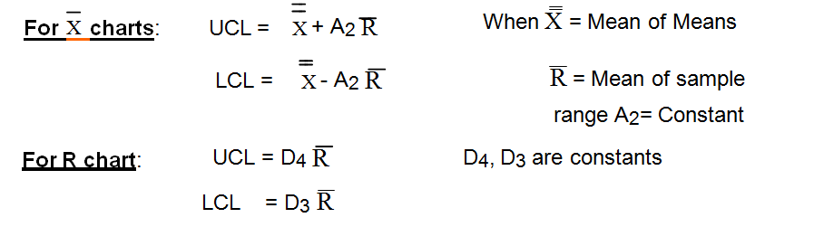

R bar is the average of sample ranges (Ranges is the difference between the maximum variable and minimum variable)

**Control charts for attributes**: The quality of attributes can be determined on the basis of ‗Yes‘or ‗No‘, ‗Go‘or ‗No go‘. In other words, in case of a mirror glass, even if there is one scratch it is not considered to be a quality mirror, in such a case quality is decided base on whether the mirror has any scratch or not.

The control charts for attributes are ‗C‘chart and ‗P‘charts

‗C‘Chart: ‗C‘chart is use where there a number defects per unit. This control charts controls the number of defects per unit. Here the sample size should be constant. This calculates as below.

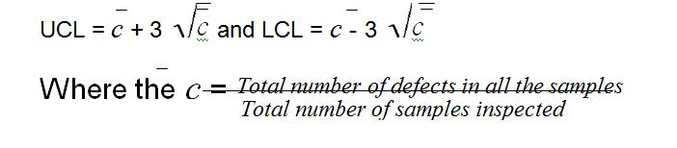

‗P‘Chart: ‗P‘Chart is used where there is data about the number of defectives per sample. It is also called fraction defective chart or percentage defectives chart. Here each item is classified on ‗go or no go basis that is good or bad. Hence if the sample size is larger, the results could be better.

*Total no*. *of defective found*

Where average defective ( *p* ) =

*Total no*. *of pieces inspected*

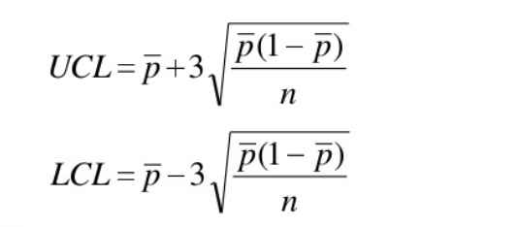

**Acceptance Sampling**: Acceptance sampling is a technique of deciding whether to accept the whole lot or not based on the number of defectives from a random drawn sample.

It is widely use in buying food products, such as rice, wheat etc. Before buying the random samples drawn from the bags of say rice are tested. If the quality of sample drawn looks good or free from defects then according to the requirement the entire bag or part of it can be brought

**Sampling plans**: Based on the number of samples drawn for taking accept/ reject decisions, the sampling methods are used. There are four methods of acceptance samplings.

1. Single sampling plan: A lot is accepted or rejected on the basis of a single sample drawn from that cost
2. Double sampling plan: If it is not possible to decide the fate of the lot on the basis of first sample, a second sample is drawn and the decision is taken on the basis of the combined results of first and second sample.
3. Multiple sampling plan: A lot is accepted or rejected based upon the result obtained from several samples (of parts) drawn from the lot.
4. Sequential sampling plan: (Item by item analysis)

Sequential sampling involves increasing the sample size by one part at a time till the sample becomes large enough and contains sufficient number of defectives to decide intelligently whether to accept or reject the lot.

**MATERIALS MANAGEMENT AND MARKETING MANAGEMENT**

INVENTORY CONTROL

INVENTORY: Inventory is ‘’An asset comprised of all materials , supplies, finished goods or goods in some stage of processing that are owned by a company , whether located physically in the premises of that company, in transit or in the hands of a distributor who has them in consignment’’.

INVENTORY CONTROL: Inventory control is the system by which inventory is managed. Inventory control may be defined ‘’ as the systematic location, storage and recording of goods in such a way that desired degree of service can be made to the operating shops at minimum ultimate cost ‘’.

PURPOSE OF INVENTORY: The following are the reasons for holding inventory,

1. To facilitate production operations, inventories are required and they are held to act as buffer between one operation and another.
2. Inventories of raw-materials and components are held for consumption during the period between recognition of need and its fulfillment. This period is called ‘’LEAD TIME’’, consequently longer the lead time the greater will be the level of inventory.
3. Inventories are also held as a precaution for increased lead times.
4. There is a speculation element in holding the inventory to meet the contingencies like price rise ,shortages and during certain period of time.
5. To meet seasonal demands.

OBJECTIVES OF INVENTORY CONTROL: The following are the main objectives of inventory control

1. To support the production departments with materials of the right quality in the right quantity, at the right time and the right price and from the right supplier.
2. To reduce financial investments in inventories.
3. To avoid accumulation of work in process.
4. To provide good customer service
5. To maximize the service levels to the operating departments.
6. To cope with perishable materials.
7. To maintain adequate inventories at the required sales outlets to meet the market needs promptly, thus, avoiding both excessive stocks or shortages at any given time.
8. To contribute directly to the overall profitability of the enterprise.
9. To make economic purchases.

ADVANTAGES OF INVENTORY CONTROL: The following are the specific advantages of inventory control

1. Introduction of a proper inventory control system helps in keeping the investment in the inventories as low as possible.
2. Ensure availability of material by providing adequate protection against uncertainties of supplies and consumption of materials.
3. Allows full advantage of economics of bulk purchase and transportation.
4. Reduces changes of going out of stock.
5. Leads to reduction in inventory levels.
6. Releases more of capital for other operations.
7. Increases profitability of operations.
8. Provide adequate service.
9. Advantage of price discounts by bulk purchasing.
10. Inventory control ensures safety against certain contingencies like strikes at supplier’s plant.
11. Efficiency of production and control can be increased if the inventories are available in the stock room.
12. Procurement of raw materials in advance facilitates the pre-operation seasoning required by some raw materials.
13. Provides flexibility to allow changes in production lines due to changes in demand.
14. The inventory control helps in replacing in production lines due to changes in demand.
15. It reduces loss due to obsolescence, deterioration spoilage, pilferage etc.,
16. It helps in calculating cost of materials used for financial calculations
17. It ensures proper distribution, timely supply classification of materials, as A,B,C items etc.

DISADVANTAGES OF HAVING EXCESS INVENTORIES:

1. Locking up of working capital.
2. More storage space is required.
3. High insurance charges.
4. High taxes.
5. Greater handling and distribution cost.
6. High cost of recording and up keeping.
7. Deterioration in quality.
8. Chances of pilferage.
9. Evaporation of alcoholic materials.
10. Results in unproductive ‘tied up’ capital for the enterprise.

It will result in to stuck out resulting into

1. Production stoppages
2. Idle machine capacity
3. Idle labour
4. Burden of fixed over heads
5. Failure to meet delivery orders resulting into loss of goodwill.

FUNCTIONS OF INVENTORY CONTROL: Following are the most important functions of inventory control

1. Ensure availability of raw materials continuously without interrupting the production process and avoid built up of stock levels.
2. Management of stores effectively: this includes layout, storing media ( bins, shelves and open space etc.,), utilization of storage space, receiving and issuing procedures etc.
3. Stock control system: physical verification, records, ordering policies and procedures for the purchase of goods.
4. Protecting the inventory from loses due to improper handling or storing of goods and unauthorized removal from stores.
5. Pricing all materials supplied to the shops so as to estimate material cost.

MAJOR ACTIVITIES OF INVENTORY CONTROL:

The inventory control is mainly concerned with the following activities.

1. PLANNING THE INVENTORIES: -- Based on the production schedule prepared from the sales forecasting and customer orders periodic requirements of inventories are planned in advance.
2. PROCUREMENT OF INVENTORIES: -- The incoming materials are received, verified with the purchase order and packing slip and are inspected to the verification of quality.
3. RECEIVING AND INSPECTION OF INVENTORIES: -- The incoming materials are received, verified with the purchase order and packing slip and are inspected to the verification of quality.
4. STORING AND ISSUING THE INVENTORIES:--The inventories procured in advance are stored till they are required by the production department. The stored inventories are issued to the respective production departments against the authorized material requirements.
5. CODING OF THE RECEIVED INVENTORIES: -- The received inventories are coded so that they are readily accessible and can be issued readily.
6. RECORDING THE RECEIPTS AND ISSUE OF INVENTORIES: -- Inventories are properly recorded in the bin card and attached to each bin and in the stock ledger. At the end of each transaction, the entries are made in the keeping or issuing columns and the balance is stroked.
7. PHYSICAL VERIFICATION OF INVENTORIES: -- At the end of specified period the physical quantities of inventories of verified with the book balance and the discrepancies are ascertained. The discrepancies are analyzed and the reasons for the inventory losses are located.
8. FOLLOW-UP FUNCTION: -- Inventory control also the analysis of excessive usage of inventories and finds out the reasons for such excessive consumption.
9. MATERIAL STANDARDISATION AND SUBSTITUTION: -- Inventory control also aims to standardize the materials and to search for cheaper substitutes.
10. CLASSIFICATION OF INVENTORY: -- Inventory control classifies the inventory into A, B and C according to their priority thus exercising the control and removing the obsolete inventory accordingly.

COSTS IN INVENTORY

Inventories cost money. The cost factor must be considered while taking any decision regarding inventories. Inventory cost includes ordering cost, carrying cost, out of stock or shortage cost and capacity cost. Each of these comprises several elements. They are:

1. ORDERING COST:--
2. Cost of placing an order with a vendor of materials:
3. Preparing a purchase order
4. Processing payments
5. Receiving and inspecting the materials
6. Ordering from the plant:
7. Machine set-up
8. Start-up scrap generated from getting a production run started
9. CARRYING COSTS:--
10. Costs connected directly with materials:
11. Obsolescence
12. Deterioration
13. Pilferage
14. Financial costs:

(1) Taxes

(2) Insurance

(3) Storage

(4) Interest

3. OUT-OF-STOCK COSTS:--

A. Back ordering

B. Last sales

1. CAPACITY COSTS:--

A. Overtime payments when capacity is too small

B. Lay-offs and idle time when capacity is too large.

Materials management also called as inventory management. ‘’Materials management is a total concept involving an organizational structure unifying into a simple responsibility of the systematic flow and control of materials from identification of the need through customer delivery’’. It includes the material functions like planning, scheduling, buying, moving and distributing.

Materials management is a body of knowledge which helps the manager in improving productivity of capital by reducing material cost, preventing large amounts of capital being locked up for long periods than it is necessary. Thus the importance of material management lies in the fact that any contribution made in reducing materials cost will help in improving the profitability and the rate of return on the capital invested.

SCOPE AND IMPORTANCE

A survey conducted by the Directorate of Industrial Statistics during 1954-57 showed that the average material cost is 64 percent of the total cost. Thus only 36 percent costs are for wages and salaries, overhead and profit etc. In some industries it cost up to 70 percent. These figures themselves show the importance of materials management.

Management of material is crucial in organizations for their success, because the cost of purchasing, storing, transporting materials account for over half of the product’s cost. Improving productivity is essential in order to retain in competition and this involves driving down the cost of all aspects of production. Since there is maximum scope of cost reduction in the area of materials, it was seen that higher productivity is achieves by management of materials effectively. Production and operations managers are working hard to determine and develop better ways of managing materials.

The importance of an efficient materials management system in an organization

1. Cost of materials is higher than other inputs put together i.e., machinery labour, power.,
2. Materials having significant impact on reducing costs and improving profits
3. Improving returns on investment depends on the effective utilization of materials and keeping down the capital invested in the form of inventory of materials, because they are treated as a major part of current asset.
4. Materials enhance product value
5. Quality of materials lead to quality of products
6. Materials management involve purchasing, transport ting, storing, inventory control etc.
7. Availability of right materials in right quantity, at the right time, at the right price from the right source of supply will increase efficiency of a firm.
8. Procurement and preservations of scarce materials ease future operations.

FUNCTIONS OF MATERIALS MANAGEMENT

Following are the main functions included under the direction and control of materials manager.

1. Materials planning and programming
2. Purchasing of materials
3. Receiving of materials
4. Inspection of materials
5. Classification , codification and standardization in stores
6. Storage of materials
7. Issuing of materials
8. Maintenance of proper inventory records

OBJECTIVES OF MATERIALS MANAGEMENT

1. To minimize the cost of materials
2. To reduce investment in stock through inventor control
3. To procure raw materials of desired quality when required at lowest possible cost of the concern
4. To purchase, receive, transport and store materials effectively and reduce the related costs
5. To trace new sources of supply and develop cordial relations with them to ensure continuous material supply.
6. To cut down costs through simplification, standardization etc.,
7. To modify paper work procedure in order to minimize delays in procuring the materials
8. To study the pros and cons of making or buying from outside
9. To prepare the materials budget and forecast the prices of materials
10. To suggest alternative materials and improve the quality of the end-product
11. To conduct studies in areas such as quality , consumption and cost of materials in order to minimize cost of production
12. To train personnel in the field of material management in order to increase operational efficiency.

CENTRALISED VS. DECENTRALSED PURCHASING

CENTRALISED PURCHASING: -- centralized purchasing means entrusting the function of purchasing the materials, plants, tools, equipments, furniture etc. To one person or department for and on behalf of all departments irrespective of its place in the organization.

DECENTRALISED PURCHASING: -- Decentralized purchasing, on the other hand, permits different plants or branches or departments to make their own purchases according to their requirements. If there is one plant is located at one place, centralized purchasing is better.

It has the following **advantages**:

1. Highly skilled official can be appointed
2. Avoids duplication of purchasing
3. More attention by heads of department of departmental work
4. Economic of large scale buying can be obtained
5. Better control over purchases.

**Disadvantages** of centralized purchasing:

1. Delay in producing of materials
2. Wrong purchases are possible
3. Not suitable in some industries
4. No advantages of local resources

Organization structure Centralized purchasing and stores

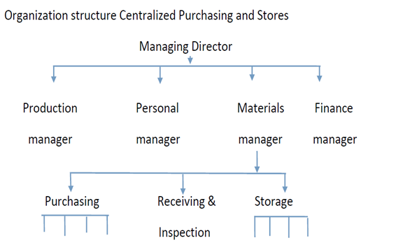

Organization structure Decentralized purchasing and stores

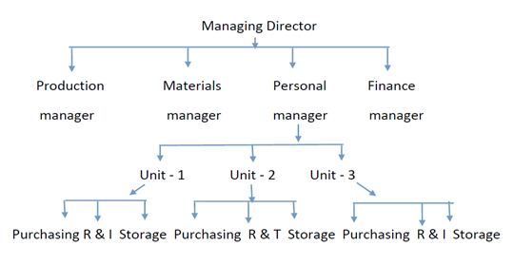

PURCHASE PROCEDURE OR THE FUNCTIONS OF PURCHASE MANAGER

Purchase means buying of materials, tools, parts etc., required by Industry.

Objectives: 1. What to purchase(right quantity)

2.When to purchase(right time)

3.where to purchase(right source)

4.Where to purchase(right source)

5.What rate to purchase(right price)

To achieve these objectives, a systematic purchase procedure should followed

PURCHASE PROCEDURE

* Purchasing requisition
* Exploring the source of supply
* Issuing of tenders and quotations
* Opening tenders
* Selection of right source of supplier
* Placing purchase order
* Follow-up
* Receiving the materials along with delivery note
* Checking inward invoice
* Inspecting and testing Materials
* Forwarding materials to stores
* Checking invoice and passing of bills for payments.

PURCHASE CYCLE

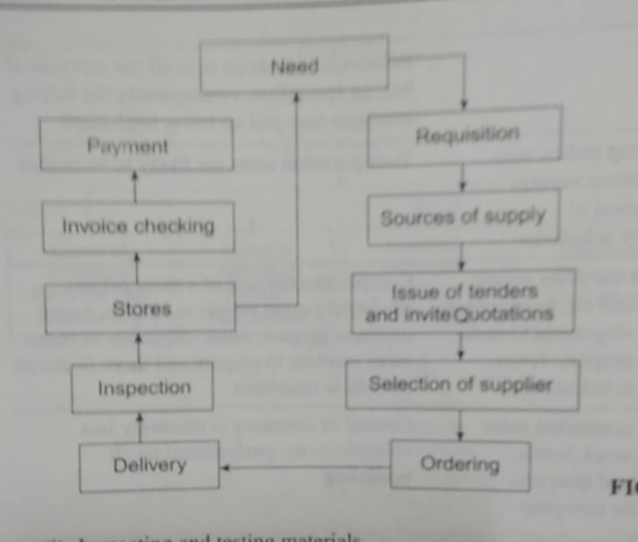

* 1.Purchase requisition: When ever department needs an item, it is officially brought to the notice of the purchase department through a requisition. The purchase requisition contains the details of the type of quality of materials required and quantity to be purchased. 2.Exploring the source of supply: For purchasing new item, reference may be made to one or more of the following from which information may be obtained. A)Catalogues B)Trade Journals C)Advertaisements D)Trade directories. 3. Issuing of tenders and quotations: The purchase department issues tenders and invite quotations from the selected suppliers. The tender mentions the particulars of details to be submitted. The details of price per unit, quantity to be supplied, time of delivery, discount, the terms of payment in the quotation. 4. Opening tenders/Quotations: After receiving a number of quotations from different suppliers, they are studied and a comparative statement of rates and other terms and conditions mentioned in the quotations is prepared. 5. Selection of right source of supplier: The comparative statement as prepared in step four above serves a good guide in selecting the right source of supply. 6.Placing purchase order: After selecting the right supplier, a purchase order is dispatched to him. The purchase order constitutes a legal document. 7.Follow-up: More often, it is necessary to follow-up periodically to ensure the timely delivery of the materials. 8.Receiving the materials along with delivery note: The goods are supplied with delivery note. 9.Checking inward invoice: Invoice is a statement showing the particulars of the supplier, the buyer of the goods supplied the details of the materials supplied, and the amount payable after adjusting the advance paid and the discounts normally allowed. The buyer receives inward invoice. 10.Inspecting and testing materials: The purchase department links up with the stores department to check the physical condition, quality and quantity of the materials received. In case of any shortage or damage, the facts should be informed to the supplier. Steps should be taken to ensure that either the damaged material is replaced or not charged. 11.Forwarding materials to stores: After inspection, the goods received are forward to the stores. 12.Chechking invoice and passing the bills for payment: Normally, the suppliers directly despatch invoice to the accounts department. The accounts department sends it to the stores department for the verification of the quality and price. After the stores department certifies, the accounts department passes the invoice for the payment.

ECONOMIC ORDER QUANTITY

Inventory control basically deals with two basic issues. (1) When to order and (2) how much to order. The problem of ‘when to order’ is decided by prescribing the reorder level of each of the inventory item. The other incidental issue is ‘how much to order’ i.e., what should be the size of each order is decided on the basis of economic order quantity.

EOQ is an important technique of inventory control. It prescribes the size of the order at which the ordering cost and inventory carrying cost will be minimum. The ordering cost consists of the cost of paper work for placing an order like use of paper, typing, posting, filing up, receiving etc., ordering cost is more or less fixed and it is ascertained on per order basis.

The other side of the scene is the inventory carrying costs. When the inventories are stored, it involves following types of costs:

1. Inventory cost due to locking up of funds

2. Cost of storage space and

3. Cost of insurance and taxes

The ordering cost and the carrying cost is mutually exclusive. If the annual requirements are met by placing a single large order, the ordering cost will be less due to single order. But as the single order will be for huge quantity, the average stock holding would be very high resulting into greater carrying cost. The relationship of ordering cost and carrying cost is as under:

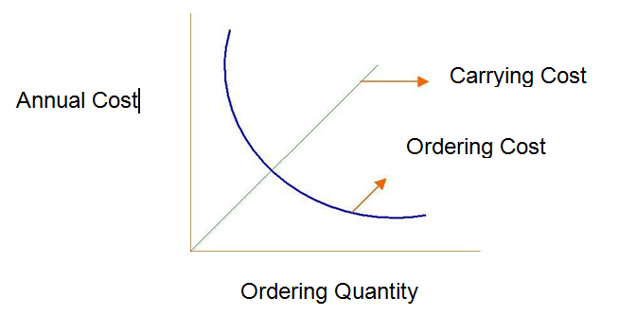

The technique of EOQ strikes a balance between the ordering cost and the carrying cost. It devices such a quantity of each order at which the total ordering cost and carrying cost would be minimum. As both these costs are mutually exclusive the total of both costs will be minimum at a point where ordering cost equates carrying cost.

Graphical representation of EOQ



From the figure it can be seen that B indicates the size of order where

(1) The total ordering cost and carrying cost i.e., A+B is at minimum. Any deviation from point B to left hand side will increase ordering cost and reduce carrying cost resulting into greater cost. If the deviation is made on right hand side from point B, it will result into increase in carrying cost and reduction in ordering cost with high total cost.

(2) At point B, the ordering cost and carrying cost equates each other. Thus, B is economic ordering quantity where the total ordering cost and carrying cost tend to be minimum.

**Assumptions for calculating Economic Order Quantity:**

1. It is assumed that demand rate is uniform.

2. Lead time is zero.

3. Production is instantaneous.

4. There is no shortage of supplies.

5. Consumption of inventory is constant.

**Economic Order Quantity Formula**:

The economic order quantity phenomenon can also be explained mathematically with the help of a formula. The formula is derived as under:

Let us define the economic order quantity variables as below.

A = Annual Demand

S = Size of each order

O = Ordering cost per order

C = Carrying cost per unit

Step – 1: Find out total ordering cost per year.

Total ordering cost per year = Number of orders placed per year x Ordering cost per year

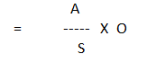

Step – 2: Find out the total carrying cost per year.

Total carrying cost per year = Average inventory level x Carrying cost per year

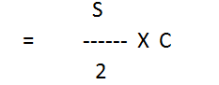

Step – 3: Determine Economic Order Quantity.

EOQ is one where the total ordering cost is equal to total carrying cost



**Benefits of EOQ**:

EOQ technique is highly useful in as much it answers the question of how much to order and in so doing establishes the frequency with which orders are placed. EOQ is applicable to both single items and to any group of stock items with singular holding and procurement costs. Its use causes the sum of the two costs to be lower than under any other system of replenishment.

**Limitations of EOQ:**

The EOQ can be determined only if the assumed conditions are in operation. But in real life situations, none of these conditions are found to be operating. Lead time vary, rate of usage, unit price and carrying costs are never constant. Moreover, companies often find it profitable to take advantage of quantity discounts. Finally safety is needed to prevent the occurrence of stock out contingencies due to delayed deliveries as well as higher than assumed rate of usage. The use of EOQ is also limited by the difficulty of estimating ordering and carrying costs. Nevertheless, the model serves a useful purpose as an approximation of real-life situations. Understanding of the machines of the model and its limitations also helps in determining economic lot size of manufactured as well as purchased items in real life situations.

**ABC Analysis**

ABC analysis is a basic management tool, which enables top management to place the efforts where the results will be greatest. This technique is popularly known as ‘Always Better Control’ and has universal applications. This technique tries to analyze the distribution of any characteristic by money value of importance in order to determine priority. Here all items of the inventory are listed in the order of descending values, showing quantity held and their corresponding value. Then, the inventory is divided into 3 categories – A, B and C, based on their respective value. The following procedure is suggested for developing an ABC Analysis:

1. Identify all the items used in an industry.

2. List all the items as per their value.

3. Count the number of high valued, medium and low valued items.

4. Find the percentage of high, medium and low valued items.

5. Select top 10% of all items which have highest rupee and designated them as ‘A’.

6. Select next 20% of all items which have next highest rupee and designated as ‘B’.

7. 70% of all items designated them as ‘C’ items.

Relationship between percentage of items and percentage of value of consumption



‘A’ category comprises of inventory, which is very costly and valuable. Normally, 70% of the funds tied up in such costly stocks, which would be around 10% of the total volume of stocks. Because the stocks in this category are very costly, these require strict monitoring on a day-to-day basis.

‘B’ category comprises of inventory, which is less costly. 20% of the funds are tied up in such stocks and this account for over 20% of the total volume of stocks. These items require monitoring on a weekly basis.

‘C’ category consists of such stocks, which are of least cost. Volume-wise, they form 70% of the total stocks but volume-wise, they do not cost more than 10% of the investment in the stocks. This category of stocks can be monitored on a monthly or bi-monthly basis.

The following table summarizes the concept of ABC Analysis

|  |  |  |  |
| --- | --- | --- | --- |
| Category | Value (%) | Volume (%) | Desired degree of control |
| A | 70 | 10 | strict |
| B | 20 | 20 | moderate |
| C | 10 | 70 | low |

**Advantages of ABC Analysis**:

This approach helps the material manager to exercise selective control and focus attention only on a few items while dealing with lakhs of items. By controlling ‘A’ items and doing proper analysis, obsolete stocks can be identified.

1. It helps to rationalize the number of orders and reduce average inventory

2. It gives a deeper cost perspective to management and enables them to decide upon priorities in improvement or cost reduction programme

3. Time and energy wasted by making improvements in ‘C’ class items is prevented

4. It results in relaxed control and less emphasis put on ‘C’ items which represent the bulk of the inventory items.

**Limitations:**

1. In order to be fully effective, ABC analysis should be carried out with standardization and codification.

2. ABC analysis indicates nothing about the profitability or criticality. Importance is given to an item on the basis of its consumption value and not on criticality. Hence such classification can lead to overlooking the need for spare parts, whose criticality is higher but consumption value is low.

3. ABC analysis should be reviewed periodically so that changes in price and consumption are taken into account.

MARKETING MANAGEMENT

**Marketing – Definition:**

Marketing is the process of identifying the customer requirements and satisfying them efficiently and effectively. According to ‘’American Marketing Association’’, ‘’Marketing is an organizational function and a set of processes for creating, communicating and delivering value to customers and for managing customer relationships in ways that benefit the organization and its state holders’’.

Marketing can also be defined as a perpetuation of social processes through which ‘’individuals and groups obtain what they need and want through creating, offering, and freely exchanging products and services of value with others’’.

**Objectives of Marketing**:

Objectives of Marketing are as follows:

1. To maximize profits and minimize losses by developing an intelligent appreciation of the modern marketing practices and the influences in the marketing situations.

2. To maintain constructive and co-operative relationships with customers based on business dealings of the highest integrity, delivery of high quality products and dependable service.

3. To recognize the need and take positive action where indicated to absolute present products and be ready with successor products.

4. To develop and sell complete packing system to strengthen total influence on the market.

5. To organize marketing services to provide maximum assistances to marketing management, maximum support to field selling at the lowest reasonable cost.

6. To provide guiding policies regarding marketing producers and their implementation.

7. To study marketing problems according to circumstances and to suggest solutions.

8. To enable successful distribution of agricultural products, minerals and manufactured goods and

9. To enable managers to assess and decide a particular course of action.

Mar**keting functions:**

Specialized activities which are performed in the marketing of goods and services are called ‘’ Marketing functions’’. Marketing function is an act by which original product and the final consumers are linked together. The functions of marketing are ‘’eyes and ears’’ of the business. Marketing functions are performed by the manufacturer and all middlemen. Marketing functions have been classified by different marketing experts in different ways. But the most acceptable and meaningful classification is given by Clark and Clark which is shown in the following chart.

Marketing Functions

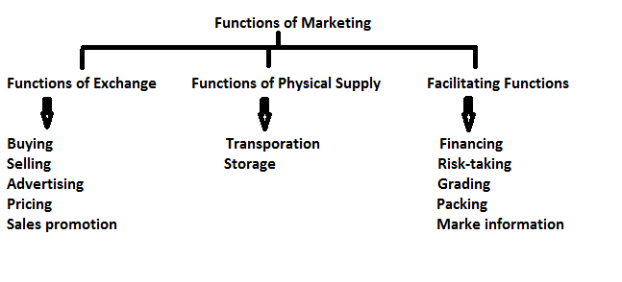

**Functions of Exchange**

These functions from the cornerstone for any marketing activity goods are produced for satisfying human wants. This is of achieved only when goods finally reach the hands of consumers. The process of the passing of goods into the consumers hand is called functions of exchange. These functions include the following.

1. **Buying and Assembling**:-

Buying and assembling of raw-material and goods are important functions of marketing.

Buying is the first step in the process of marketing. Raw materials are purchased for use in manufacturing by the manufacturing enterprise and goods are purchased for re-sale purpose by the trading enterprises. In both the cases, the marketing department has to play an important role

Assembling is different from buying. It begins after the goods have already been purchased. Assembling facilities transportation and storage.

2. **Selling**: - Selling is the heart of marketing. The purpose of all marketing activities is to sell the goods or services. Selling enables an enterprise to satisfy the need of the customer and there by achieve its objectives. Selling is the process of finding the consumer, creating demand and transferring the goods for value.

3. **Pricing**: - Pricing is also an important function which is closely related to selling. Pricing policy directly affects the sales and profitability of the concern. The pricing policy may be cost based, demand based and it varies one to the other.

4. **Advertising**: - Advertising is nothing but a paid from of non-personal presentation of ideas, goods or services by an identified sponsor. In the present day business advertisement has become an inseparable part of business activities, as it affects the whole marketing strategy of the firm.

5. **Sales promotion**: - Sale promotion refers to all those marketing activities other than advertising, personal selling and publicity that stimulate consumer purchasing and dealer effectiveness. Consumer promotional activities may be in home promotional schemes such as samples, demonstration, coupons etc., dealers promotional activities include discount on purchases, display and advertisement allowance, prizes and gifts etc.,

**Functions of physical supply**: - These functions relate to the process of transporting the goods from the place of seller to the place of the buyer. The functions include the following.

1. **Transportation:** - Transportation involves the carrying of goods and people from one place to another. It is an integral part of the process of marketing. It helps in assembling and dispersing the goods. It links together the producer and consumer who are located at different places. By carrying the goods to such where there are needed, it creates place utility.

2. **Storage or Warehousing**:- Storage refers to the holding and preservation of goods till they are dispatched to the buyers. Generally there is a time gap between the production and consumption of goods. By bringing the gap between production and consumption, storage creates time utility.

**Facilitating functions**:- These functions make the marketing process easy. These functions include the following.

1. **Financing**: - Finance is the life blood of business. Value of goods is expressed in money and it is denoted by price to be paid by a buyer to a seller. Without finance, the whole marketing activity may come to a standstill. Therefore, for exchange of goods and services and for any other marketing activities finance is a vital aspect.

2. **Risk taking**: - One of the important functions of marketing management is risk-bearing. In a marketing activity uncertainty is bound to exist. This uncertainty may result in the form of either loss or profit. Some of the risks may be avoided by taking insurance coverage.

3. **Marketing information**: - This is a recent function added to marketing. Marketing information is a vital resource in business for taking marketing decisions. Marketing executives are expected to know the trends in market demand, supply, prices and related market information. If the form is equipped with latest market information, risk of loss can be reduced. Modern means of communications such as computer based marketing information system can be adopted for adequate, up-to-date, reliable and timely information.

4. **Marketing research**: - The systematic gathering and analysis of information relevant to a problem in marketing is known as ‘’marketing research’’. It includes demand analysis, sales forecasting and research connected with actual and potential buyer’s present and future products.

5. **Standardization and grading**: - Standardization means determining basic limits to different classes of products. It involves establishing measures for different grades of a product. Standards may be established on the basis of size, color, appearance, strength, shape etc. Standard conveys the idea of uniform quality.

Grading refers to sorting of products into different lots, each of which has substantially same characteristics with respect to quality. Grading helps the buyers to select the most suitable product for their use.

6. **Packaging**: - Packaging is an act of designing and producing the package for a product. Package is a container in which a product is enclosed. In modern marketing, packaging performs a number of functions, such as protecting products from spoilage, deterioration, helps brand identification, helps product handling and communicating the product information etc.,

7. **Branding:** - Branding is a sub-function of selling. In competitive economy, a number of producers the same type of goods. Every producer tries to identify his goods from those of the competitors by using a brand. A brand is defined as a name, term, symbol or design which is intended to identify the goods of one seller and to differentiate them from those of its competitors. Branding means identifying goods with a brand name.

Thus marketing is a varied and complex process involving several functions and activities concerned with the creation of time, place and possession utilities. Production is meaningful only when subsequent marketing functions are performed most effectively and efficiently.

DIFFERENCE BETWEEN MARKETING AND SELLING

Selling:- selling is an indispensable part of marketing. The purpose of all marketing activities is to sell the products of the firm. Selling enables the firm to achieve its objectives by satisfying the needs to the customers. Selling means finding the customers and transferring them the goods for value. It is the process whereby goods finally go to the customers to meet their needs and wants.

Selling has become a very complicated function of marketing these days. There are a large number of substitutes available in the market, and there is severe competition in the market. A firm has to devise such a marketing strategy that enables it to sell its products. It has to keep in touch with the buyers to inform them the goods, and get orders from them. Thus, selling is an important function of marketing.

Marketing:- Marketing is much wider than selling and much more dynamic. Marketing means a total system of interacting business activities designed to plan, price, promote and distribute want satisfaction products and services to the present and potential customer. Marketing is the process comprising of all those activities that are related to the free flow of goods and services from the point of production to the point of consumption. It is a gigantic machinery to move the goods and services by creating utilities of place, time and ownership. Marketing consists of serving and satisfying the needs of customers.

**Distinction between Marketing and Selling:**

Very often these two terms selling and marketing are synonymously used, but they actually differ in their meaning. In the words of Edward G. Koch, the difference between selling and marketing is more than semantic exercise. Selling focuses on the needs of seller, while marketing on the needs of consumer. Selling means moving the products, while marketing means obtaining customers. The difference between selling and marketing may be summarized as below:

|  |  |
| --- | --- |
| Selling | Marketing |
| 1. Selling focuses on the needs of the seller to convert his products into profits. It starts with the seller. | 1. Marketing focuses on the needs of the purchaser. It starts with the buyer. |
| 2. It refers to moving the products from outlets. | 2. It refers to obtaining the consumers to move the goods. It starts out with the customer, his needs, values, habits, feelings and hopes. |
| 3. It gives supreme importance to the product. | 3. It gives unique importance to the customer. |
| 4. It emphasis on corporate objectives. It views business as a ‘’goods producing process’’. | 4. It emphasis on consumer satisfaction. It views business as a ‘’customer satisfying process’’. |
| 5. It aims at short-term objectives as it is only a tactical and routine activity. | 5. It aims at long-term objectives as t has strategic implications. It is purposeful directed towards the broaded and long-range objectives like growth, customer loyalty, innovation and leadership, survival and so on. |
| 6. It aims at customer-oriented selling efforts. | 6. It aims at market-oriented selling efforts. |
| 7. It gives top priority to sales volume and maximization of profits. | 7. It gives top priority to profitable volume of sales and market share at fair and reasonable prices. |
| 8. Sellers convenience dominates the formulation of the ‘’marketing-mix’’. | 8. Buyer determines the shape of ‘’marketing-mix’’ should taken. |
| 9. Selling activities are organized and directed by marketing department. | 9. Marketing policies and strategies are directed by the top management. |
| 10. Selling philosophy considers all customers as a homogeneous mass with relatively static needs, wants, tastes and buying habits. | 10. The marketing philosophy differentiates groups of customers in terms of their several distinct characteristic customers are viewed with respect. |

MARKETING MIX

**Marketing-mix –Meaning:-**

The identification of demand and supply involves various functions of marketing and the combination of these functions is known as Marketing-MIX. There are literally dozens of marketing mix tools but Mc Cathes popularised a 4 factor classification of these tools called the 4 p’s which constitute the core of a company’s marketing system, the product, the price structure, the promotions activities and the place (distribution system).

The elements of the marketing mix:

1. Product mix 2. Price mix 3. Promotion mix 4. Place mix

1. Product mix:- The word ‘’Product Mix’’ is used to describe the assortment of different product types and their varieties. In addition, different tangible and intangible features of the product also form the product mix. A firm may be producing many types of products and in different varieties. For example: Hindustan Machine Tools (HMT) consists of diverse range of products. Such as machine tools, tractors, watches, printing machinery and electric lamps and the group of all these products are called product-mix.

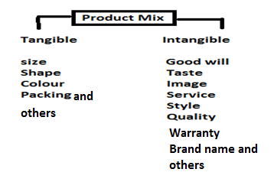

Product is anything that is offered to the market for sale at a price. It can be physical product like toothpaste or a service like transportation, education, insurance, healthcare, entertainment, repairs, etc. The physical product can be further subdivided into two, as follows:

Types of products:

Consumer products:- Goods bought by individual households without requiring further processing are known as consumer goods. These can be further categorised as:

* Durable goods: Which survive many uses and relatively long life (e.g., refrigerators, fans, watches etc.)
* Non-durable goods: Which are consumed in one or a few uses and last a relatively short period (e.g., soft drinks, soaps, bread, etc.)
* Convenience goods: Which are frequently purchased with minimum of efforts in deciding (e.g., newspapers, tooth brushes, etc.)
* Shopping goods: Which are bought after comparison at the retail outlets (e.g., garments, furniture, etc.)
* Speciality goods: Which have unique features and therefore, require special purchasing efforts (e.g., sporting equipments, cars, etc.)

Industrial products:- Industrial products are goods, which are sold to other business firms, either for their own consumption or for producing other goods. They can be either capital goods- machines and plants, or raw materials and parts.

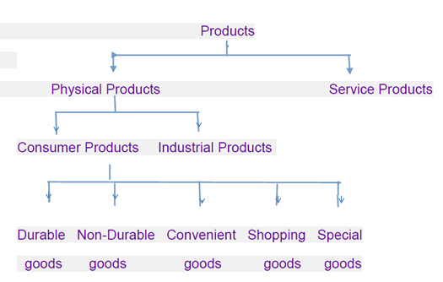

2. Price mix:- Price-mix refers to the decisions relating to the price charged for the product, service or idea. Price means the money value that the customer has to pay in exchange for a period. Generally, marketers pay attention to the following factors before fixing the price of a product.

Target customers: How much they will buy at various processes

Cost: How much it costs to produce and market the product

Competition: Intense competition may indicate a low price and vice versa

Discounts and allowances: How much of the price could be allowed as incentives to dealers and customers in the form of discounts and the profit margin to be maintained.

Producing Pricing:

Pricing decisions are extremely important as they greatly influence the profitability of a firm. Moreover, price is perhaps that handiest tool available to a firm to adopt its marketing strategy to changes in demand, cost, and competitive situations. Many factors, both economic and non-economic, influence the pricing decisions. These are:

Cost, Demand, Competition, Government regulations, Behaviour of the consumer, and Objectives of the enterprise.

Pricing Methods: There are several methods of pricing a product/service. An enterprise can adopt any one of these methods depending upon the above-mentioned economic and non-economic factors. The important pricing methods are:

1. Mark-up or Cost plus Pricing: Under this method, total cost is added up, both fixed and variable, and cost per unit is found. Then a margin of profit is added to determine the selling price.

2. Perceived Value Pricing: According to this, the product is priced on the basis of the buyer’s perceptions of value of product rather than the cost of production.

3. Going Rate Pricing: In this case, an enterprise basis its price largely on competitor’s price. The smaller firms always tend to fallow the leader and price their product more or less equal to the price of the leading product. This is most popular method of pricing and ensures competition.

4. Odd Pricing: Setting the price at extreme higher end of a particular lower price range instead of beginning of the next price range. The best example can be taken is Bata Pricing (e.g., pricing at Rs. 299.95 instead of Rs. 300.00)

5. Discriminating Pricing: Pricing the same product two different levels is known as discriminating pricing. Under certain conditions firms adopt this method of pricing.

6. Promotional Pricing: Provision of cash rebates, sales discounts, special event rebates, low-interest financing, free coupons, offering gifts and prizes, etc. Come under promotional pricing.

7. Skimming Pricing: Price heavily in the initial period of product launching and gradually reducing the same is known as skimming pricing. This is generally applied in case of products, which are subject to obsolete in a short period, eg. Computer software.

8. Penetrating Pricing: Charging low price initially and once the product is accepted by the market, increasing the same gradually is known as penetrating price. Many products are generally based on this method of pricing.

3. Promotion Mix:- Promotion mix refers to the activities relating to promotion of the product, service or idea. It consists of all activities aimed at encouraging and motivating the consumers to buy the product. The various elements of the promotional mix are:

1. Advertising: Advertising consists of all the activities involved in presenting product information to customers. The product message is communicated through media (newspapers, radio, television, etc.) and is paid for by the seller.

2. Sales Promotion: It is the method of increasing the sales through displays, demonstrations, contexts, coupons etc. Sales promotion activities aim at supporting personal selling and advertising efforts.

3. Personal selling: Personal selling is the face to face communication between a seller and a buyer. Some contacts are made with the customers by company sales representative. These representatives assist and persuade a prospective buyer to buy a product in a face to face situation.

4. Publicity: Publicity refers to the mention of a company brand or product in trade journals, newspapers, radio etc. Which is not paid for? Publicity is a relatively minor form of promotion because the manufacturer has no control over what the media will mention.

4. Place or Physical distribution mix: - Place or physical distribution mix refers to the activities that are involved in transferring ownership to consumers and to make products or services available at the right time and place. Distribution mix consists of two things.

a) Physical distribution and

b) Channels of distribution

Physical distribution includes all those activities involved in moving products or services from producer to consumer.

The channels of distribution are those routes through which goods move from the producer to the consumer. Here, the marketing manager has to decide whether the firm should sell through middlemen or directly to customers.

CHANNELS OF DISTRIBUTION

A channel of distribution for a product is the route taken via the marketing institutions (agents, brokers, wholesalers, retailers) by the title to the goods as they move from the producer to the ultimate consumer or industrial user. A channel always includes both the producer and the final consumer for the product, as well as all agents and merchant middlemen involved in the title transfer.

The entire function of getting goods into the hands of the consumer is often referred to as distribution. The term channel of distribution is used to denote the middlemen engaged in moving goods from the place of production to the place of consumption. It is the channel through which goods are move as smoothly as possible to the desired places.

Choice of Channels of Distribution:- (Functions of channels of distribution)

The choice of channels of distribution is an important marketing decision of an organization. The following points are taken into the consideration while choosing channels of distribution.

1. The cost involved in the use of channel is included in price and the customer has to bear the cost. So proper decision should be taken.

2. Depending on the type of product.

3. Size and structure of manufacturing concern.

4. Company considerations which include reputation, financial resources, experience and competence of management and the desire for control of channel.

5. The existing establishment network of distribution

6. Depending on type of distribution desired by manufacturer like extensive distribution, selective distribution and exclusive distribution.

7. The profit criteria

Factors Affecting the Choice of Channels of Distribution:-

The following are the factors that affect the choice of a channel:

* The type, size, and nature of customer’s demand: If the customer wants small quantities, long channels are preferred and vice versa.
* The nature of company’s business: Choose the channel according to the nature of business activity such as agricultural products, industrial products, services, and so on.
* The type of product sold: The goods may be consumer goods(such as bread), consumer durable goods(TV or refrigerator) or producer or industrial goods(engines, shock absorbers, bearing) and others.
* The price of the unit of sale: If the price of one unit is as high as that of an aeroplane, the producer can contact the consumer directly.
* The profit margins and mark-ups: These, together with the extent of the seller’s product line, play a role in attracting distributors to handle the goods.
* Degree of competition: If the competition is intense, the manufacturer has to arrange for even door-to-door selling or retail outlets such as automatic vending machines at prominent, busy, and crowded places.

Major channels of distribution:-

There are several alternative channels of distribution to choose from. The proper selection of a distribution channel depends on such factors as the nature of the product involved, market, sales volume for each outlet, relative distribution costs, and how much of the marketing function the manufacturer wants to assume. But the most frequently used channels are Consumer Market and Industrial Market. In each channel, a manufacturer or producer may use his own sales branches or personal to reach the next institution.

Distribution of Consumer Goods:

Five channels are widely used in the marketing of consumer products. In each, the manufacturer may in addition use sales branches or sales depots. Furthermore, whenever wholesalers are used, goods may be distributed from one large wholesalers to several sub-jobbers and then to retailers. The distribution channels are,

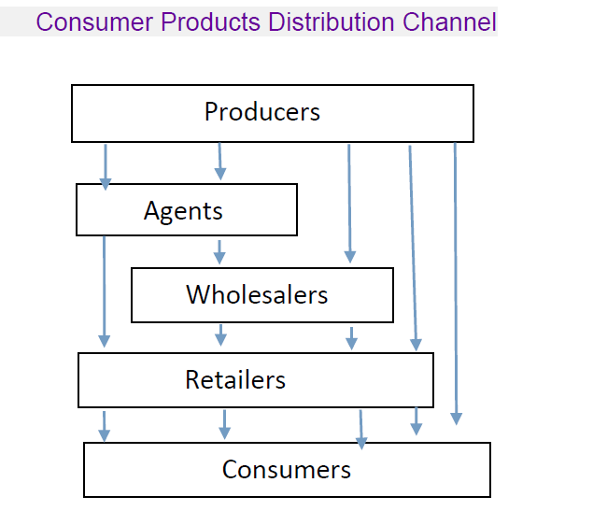

Manufacturer –> Consumer:

The shortest, simplest channel of distribution for consumer products is from the producer to the consumer, with no middle men involved. The producer may sell house-to-house, or may sell by mail. This is also called as ‘zero’ channel.

Manufacturer –> Retailer –> Consumer:

Many large retailers buy directly from manufacturers and agricultural producers. Also, some manufacturers have established their own retail stores e.g., HMT, Bata Shoe Co., Jay Engineering Company for the sale of Usha Sewing Machines and fans.

Manufacturer –> Wholesaler –> Retailer –> Consumer:

This is the ‘’traditional’’ Channel for consumer goods. Most of the consumer products where sales volume is very high and which requires a large network to operate like that of soaps, pastes, detergents, cosmetics etc.

Manufacturer –> Agent –> Retailer –> Consumer:

The tendency to adopt this type of distribution channel is an outcome of the manufacturers inability to find wholesaler to handle his products on reasonable terms and conditions. For this reason the manufacturer uses agents or brokers instead of wholesalers. E.g., Cement manufacturer.

Manufacturer –> Agent –> Wholesaler –> Retailer –> Consumer:

Manufacturer of mass consumption goods having a nationwide market do not want to deal directly with a large number of wholesalers. They appoint sole selling agents for various geographical regions who in turn sell it retailer and finally retailer sells to consumers.

Distribution of Industrial Goods:

The channels used for distribution of industrial goods differ from those channels used for consumer products because in case of industrial goods the industrial customer generally buys in bulk based on his annual consumption and inventory policy. There are basically 4 types of distribution channels which are found in the marketing of Industrial goods. The distribution channels are,

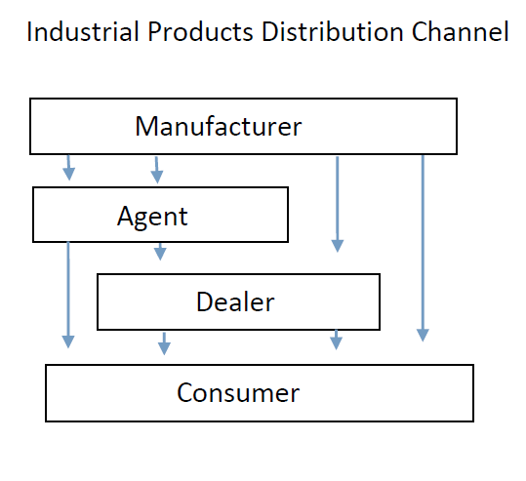

Manufacturer –> User or Consumer:

This direct channel accounts for a greater money volume of industrial products than any other distribution structure. Manufacturers of large installations, such as locomotives, generators, etc., usually sell directly to users.

Manufacturer –> Distributor –> Consumer:

Manufacturers of operating supplies and small accessory equipment frequently use industrial distributor to reach their markets. Manufacturers, building materials, construction equipment, and air-conditioning equipment make heavy use the industrial distributor.

Manufacturer –> Agent –> Consumer;

Firms without their own marketing departments find this is a desirable channel. Also, a company which wants to introduce a new product may prefer to use agents rather than its own sales force.

Manufacturer –> Agent –> Distributor –> Consumer:

Manufacturers of new products use agents and the manufacturer does not have a sales network for them. The advantage of using agents is that, it is less expensive and they have their own sales department. Agents act as sales force between manufacturer and distributor.

PRODUCT LIFE CYCLE

A product is a physical good or service or more often, a combination of both. It is capable of satisfying the buyer’s needs. It has certain tangible and intangible attributes that a seller offers to a potential buyer. It is very interesting to observe the changes in the sales of the product or service once it is launched. It is not necessary that it will have uniformity in case of every product or service. In most of the cases, sales levels will grow up to a particular point of time, and remain static at some level, beyond which the sales start declining particularly when a new product that satisfies the customer’s needs better emerges.

The concept of product life cycle describes these common patterns of sales growth and decline, that can be observed over the life time of a product.

Definitions:

Product life cycle has been defined by Philip Kotler as ‘’ an attempt to recognize distinct stages the sales history of the product’’,

According to D.T.Kollat and J.F.Robenson, product life cycle is ‘’ a generalized model of sales and profit trends for a product category over a period of time’’.

Key elements of product life-cycle:

The product life cycle is a concept that attempts to describe a products sales, profits, customers, competitors and marketing emphasis from its beginning until it is removed from the market. The concept was popularised by Theodore Levitt in 1965. The product life cycle concept has 3 key elements. They are:

1. Products move through the cycle of introduction, growth, maturity and decline at different speeds.

2. Both sales volumes and unit profits rise correspondingly in the growth stage, and fall correspondingly after maturity stage. However, during the maturity stage, sales volume rises but unit profits fall.

3. The functional emphasis required for successful product management change from stage to stage on account of changes in the economics of profitability.

**Stages of Product Life Cycle:**

Every product or service has a defined life cycle with distinct stages. These stages include

1. Introduction 2. Growth stage 3. Maturity stage 4. Saturation stage 5. Decline stage.

1**. Introduction**:- This is the very first stage of the life cycle of a product. At this stage, the product is introduced into the market. At this stage, there may not be a ready market for the product. The product is made known to its potential consumers through various programmes of advertisement. At this stage sales revenue begins to grow but the rate of growth is very slow. Profits may not be there because of low sales volume and distribution costs. This stage is the most risky stage and expensive as there is a high percentage of product failure in this period. This stage is also called market pioneering stage.

2. **Growth stage**:- This is the second stage of product life cycle. In this stage the producer is produced in sufficient quantity and put in the market without delay. The demand generally continues to outpace the supply. The sales and profit curves rise often at a rapid rate. Competitors enter in the market in large number and prices may come down slight sellers shift of ‘’ buy my brand’’ rather than ‘’try my product’’ promotional strategy. This stage is also called market acceptance stage.

3. **Maturity stage**:- At this stage the customers like and prefer the product. Total volume of sales goes or increasing but the rate of increase in the volume of sales declines. The reason of such decline is the entrance of some new competitors into the market. At this stage, the expenditure of the enterprise on advertising and sales promotion should be increased. So that the demand of product may be maintained. At the same time, the price of the product should be reduced due to the increase in competition. Consequently, the rate of profit of the enterprise declines. Low prices, keener competition, rising costs, and declining profits are the features in this stage.

4. **Saturation stage**:- When the sales growth slows down to zero, such a stage is called saturation. The size of the market does not increase beyond this stage. This stage continues till substitutes of the product enter into the market. The production goes on increasing and the competitors try to capture the market. Markets are highly segmented the cost of advertisement and sales promotion increase and consequently the profits of the enterprise decrease.

5. **Decline stage**:- When sales of a product tend to fall, such a stage is called decline. In this stage, the product loses its distinctiveness and dies out in terms of both sales and profit margins, sales drop severely. The important reasons for the decline of the sales of the product are shifts in consumer tastes, technology and increased domestic and foreign competition.

The product life of a product is depicted below:

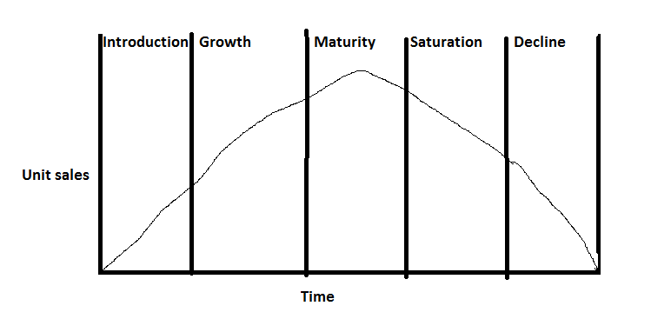

Importance of product life cycle concept:

Importance of the study of product life cycle are:

1. Predictive tool:- Since a product has a predictive life pattern and the problems likely to be encountered in different stage of product life cycle are known, the management is pre-warned of the likely changes in the product position. For ex. Behaviour patterns of sales, profits, dealers and competitors in different stages are known.

2. Planning tool:- The study of product life cycle is an important tool in the hands of management. The management is better placed to plan its strategy in advance so as to fully exploit the product potential.

3. Control tool:- The study of product life cycle help in controlling the marketing activities of the enterprise also. With the help of this study, the marketing manager can make necessary arrangements to make the product available according to the demand. Thus, the product life cycle study serve as an important control tool.

4. Development of new products:- The study of product life cycle is very helpful in the development of new products, and in the improvement of existing product. This study helps the changes taking place in the need, habits, tastes and attitudes of consumers. Keeping in view these changes, necessary decisions may be taken for the improvement of existing products, and development of new products.

Thus, the product life cycle concept is an important forecasting, planning and control tool in the hands of marketers. It is a reliable aid in modifying the marketing strategies. It is quite useful to the marketers .